

**CMPE-277: Smartphone App dev**

**Android Services**

|  |  |
| --- | --- |
| **Submitted To** |  |
| Prof. Chandrasekar Vuppalapati |  |
| **Date of Submission** |  |
| 4th April 2017 |  |
| **Submitted By** |  |
| Pooja Shah  010828311 |  |

**Objective:**

The purpose of the App is to use Android Services (background) to download files using both **Started Services and Bound Services.**

**Project Code:** <https://github.com/poojashah89/CMPE-277-Android-App-Development/tree/master/Ass6-ServiceApp>

**PART I: Using Started Intent Service**

Figure 1 shows the MainActivity

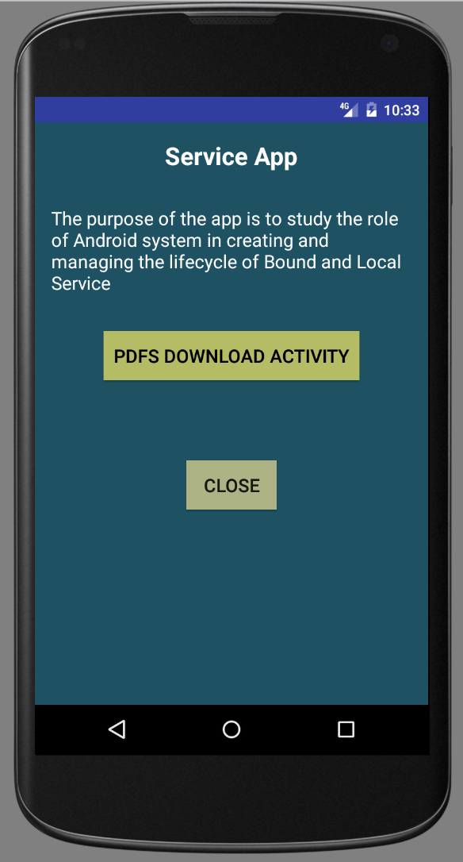

Fig 1. Application

After clicking on PDFs Download Activity from first screen, application will check if it has permission to store the files in the system. If you click allow, then only pdf will be stored on system.

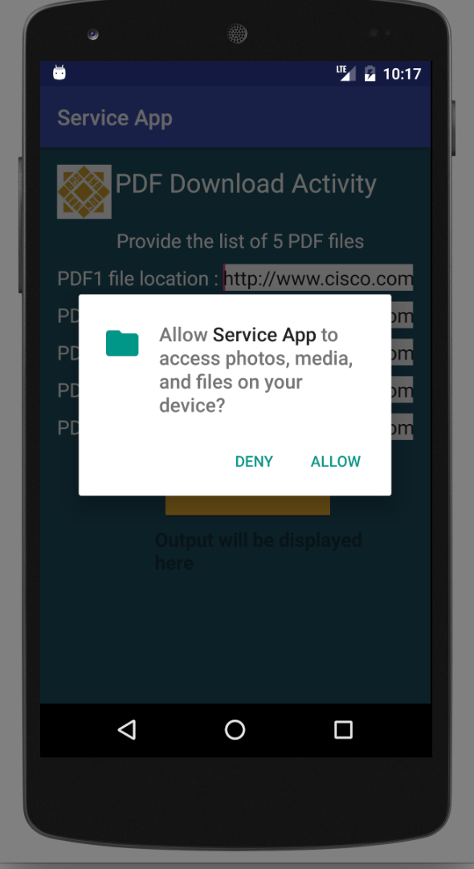

Fig 2: Android Marshmallow asking for permission to storage

Figure 3 shows the screen with inputs for PDF file location.

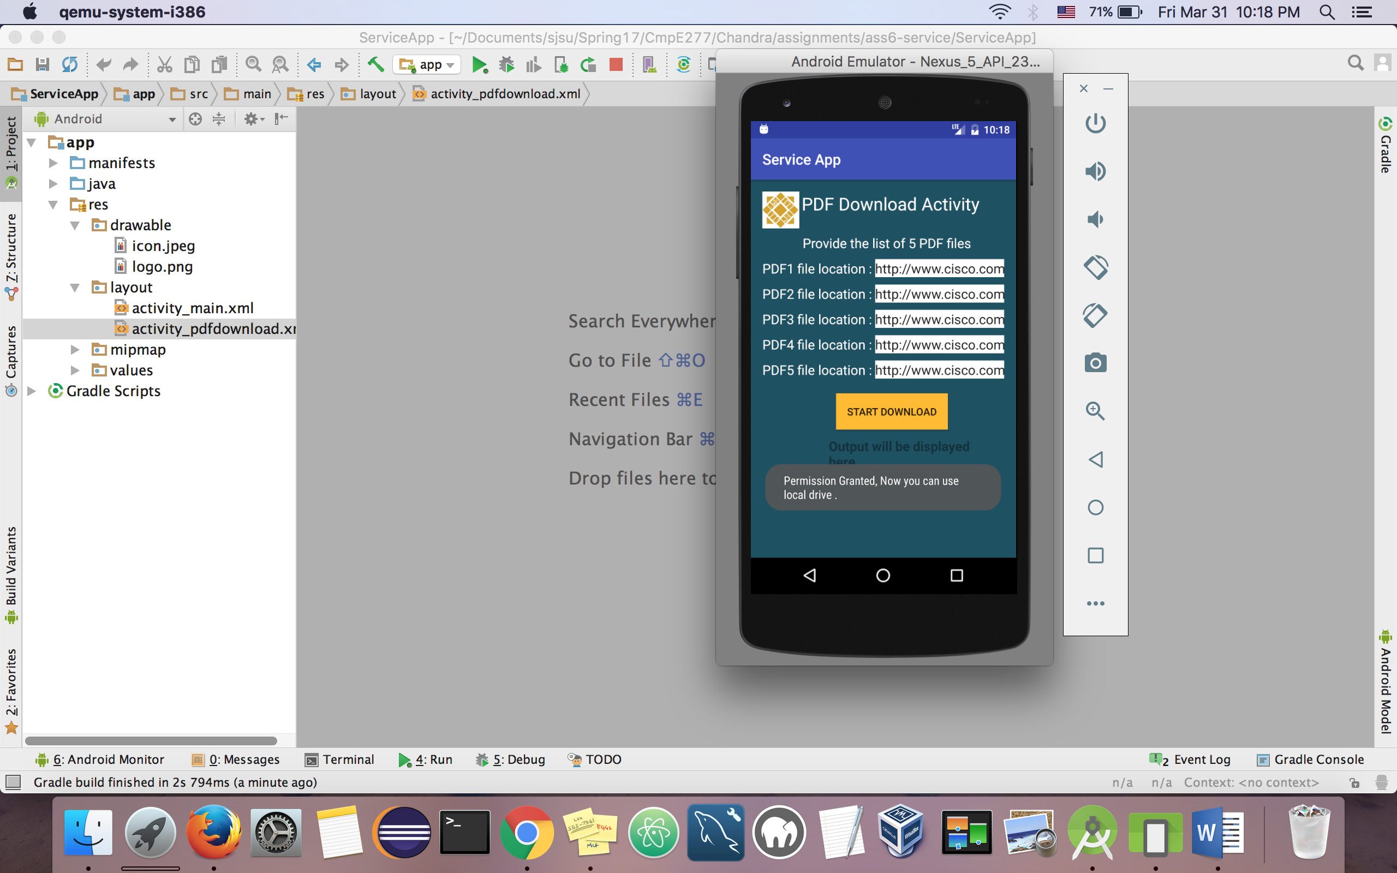

Fig 3. Permission granted and PDF inputs

Figure 4. shows that the Service App has the storage permission because we clicked on “Allow” in previous step.

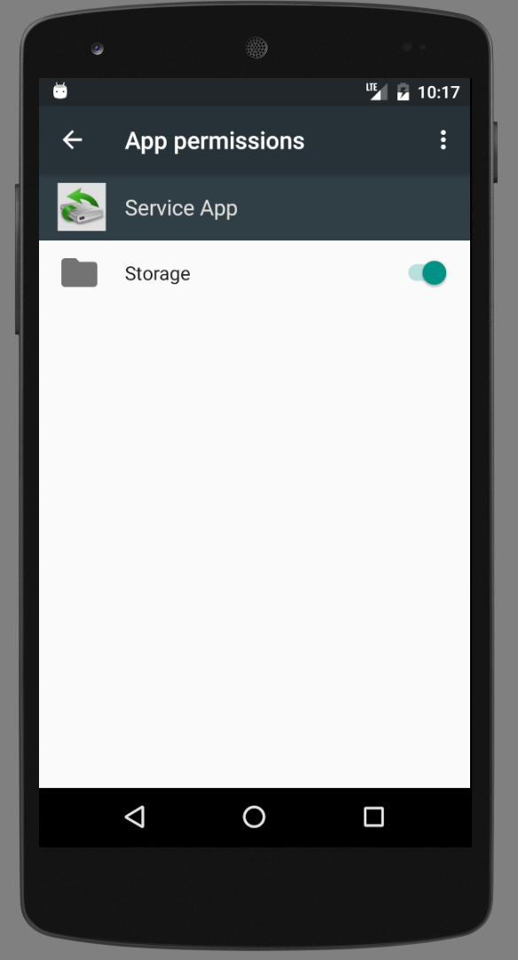

Fig 4. Service App with permission

Fig 5 : After downloading is started, files are now stored in the system. Scrollable Status section gives you the report with SUCEESS/FAIL downloading.

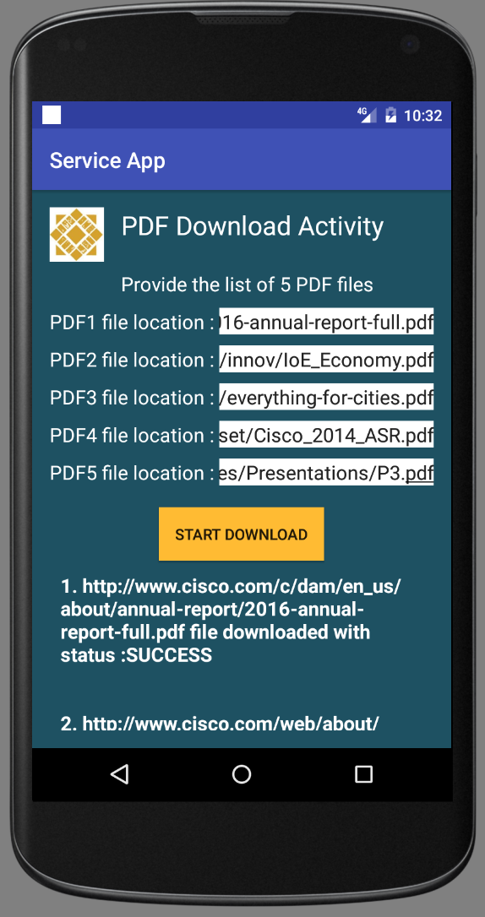

Fig 5. After downloading

Fig 6 shows the notification status of downloaded files after completing.

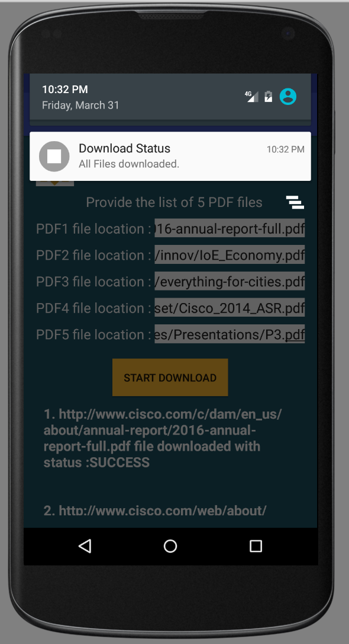

Fig 6. Files downloaded notification

Fig 7 will show you the files are now downloaded and saved in the system

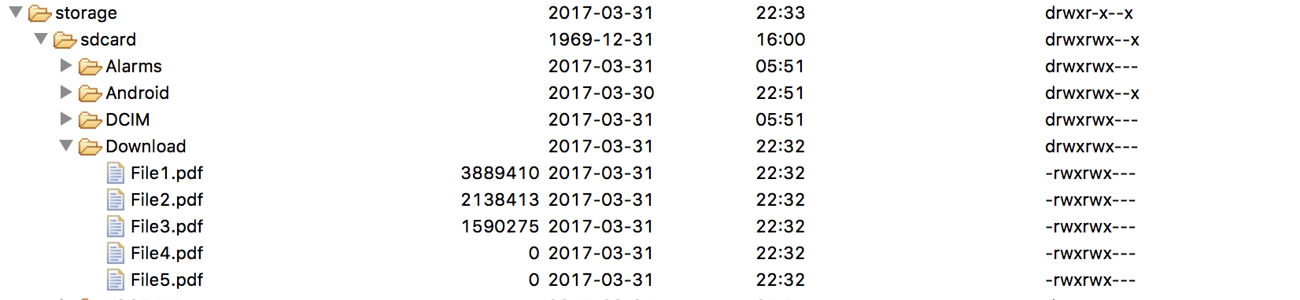

Fig 7. Downloaded files in Android Device Monitor

**PART II: Using Bound Service**

Figure 8 & 9 shows downloading in progress.

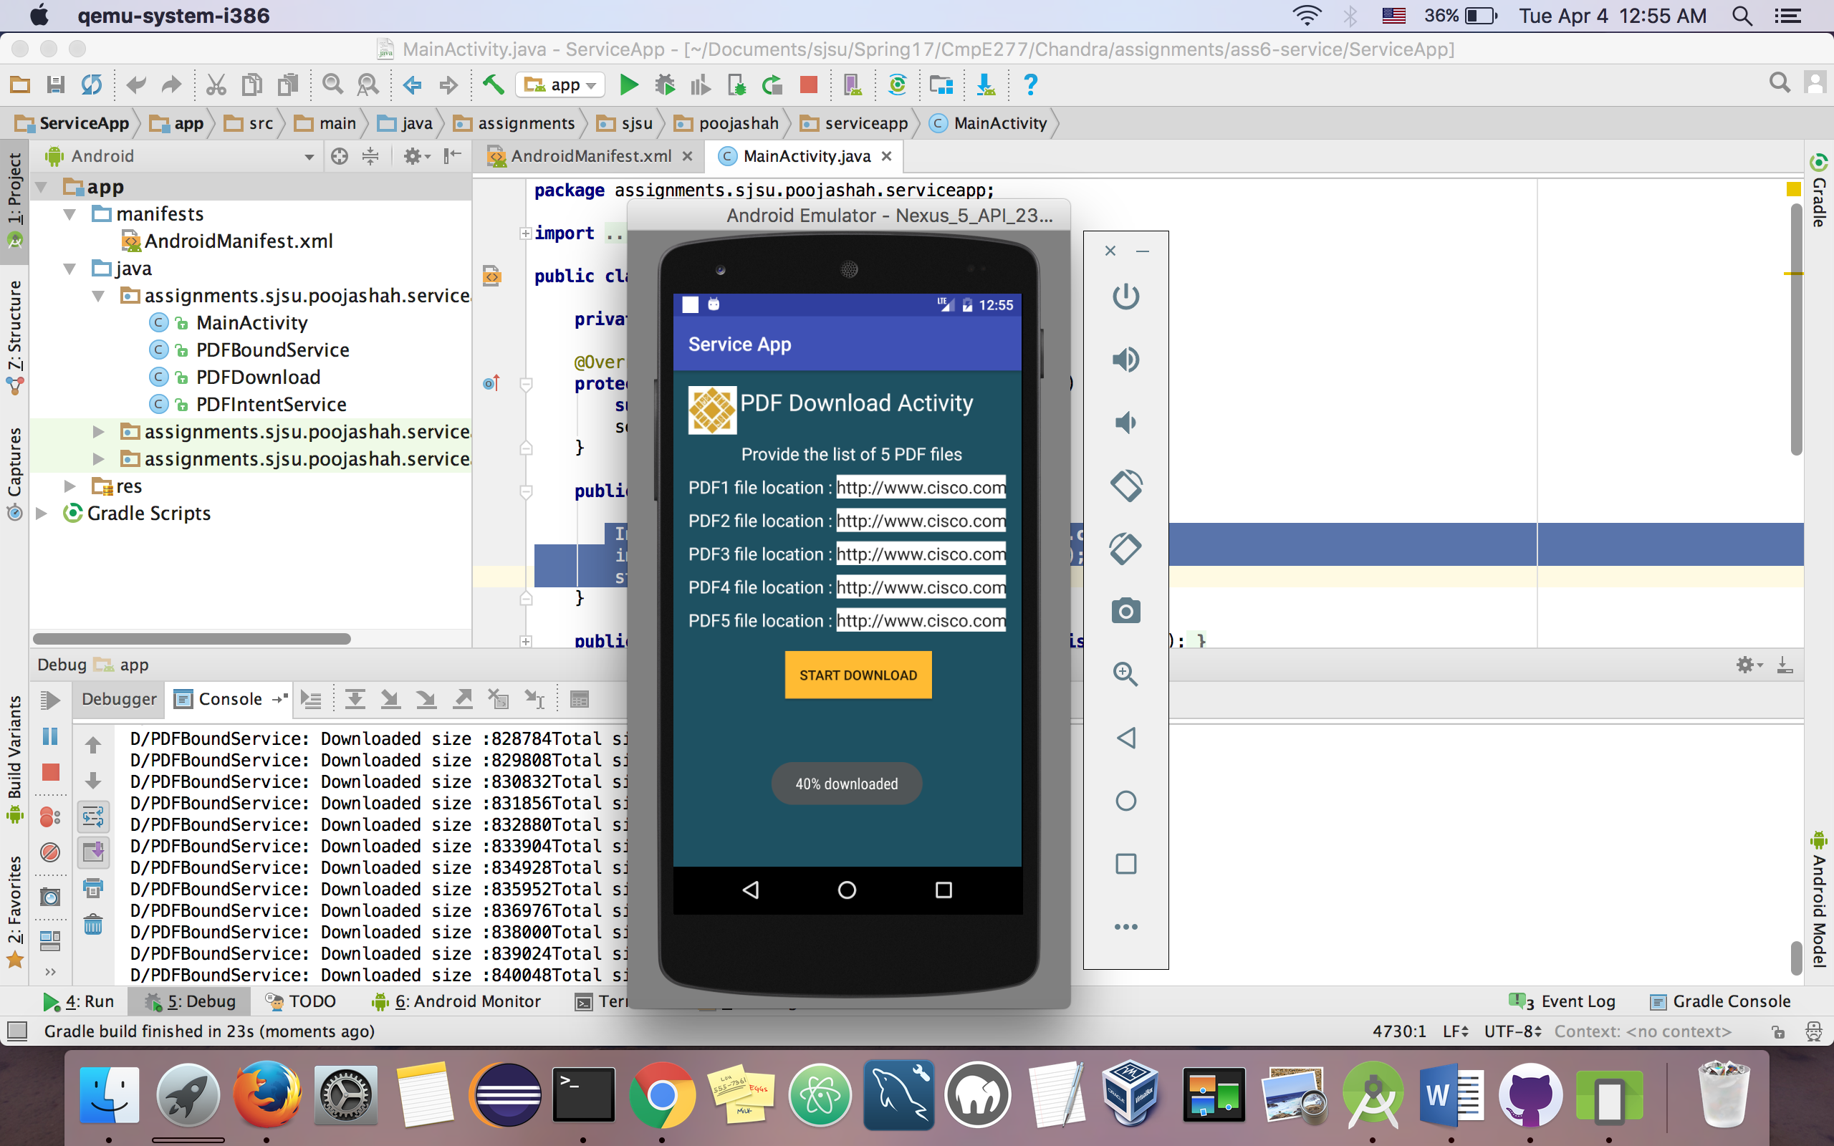

**Fig 8**

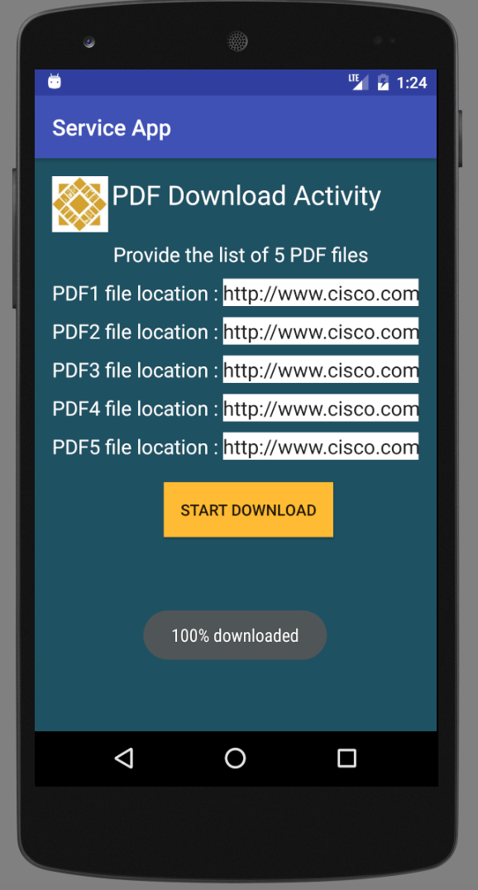

Fig 9 100% Downloaded

Figure 10 shows the completion

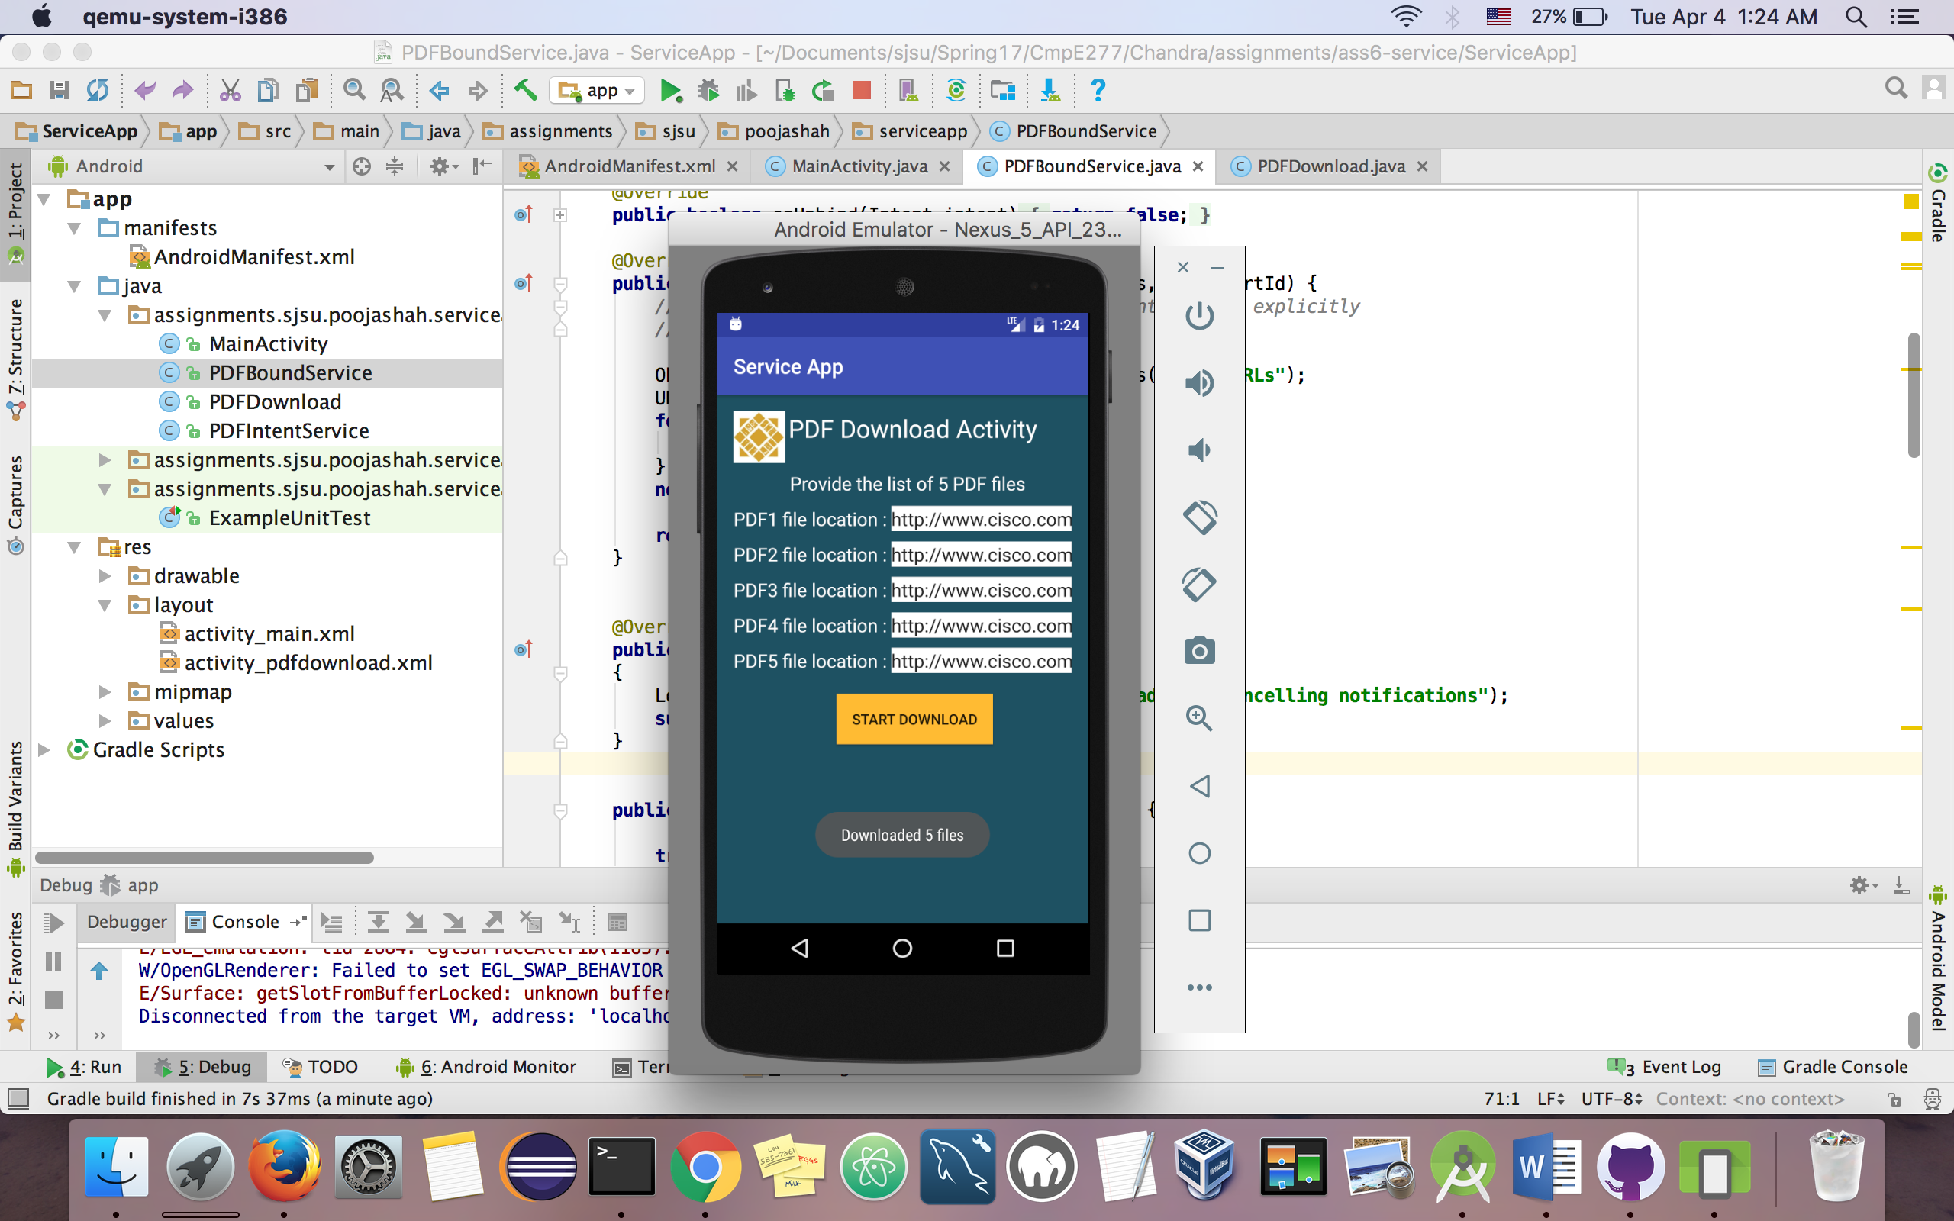

Fig 10. All 5 files downloaded